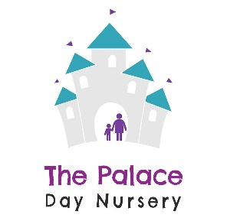

Registration Form
‘Learning is fun for the Palace Children’
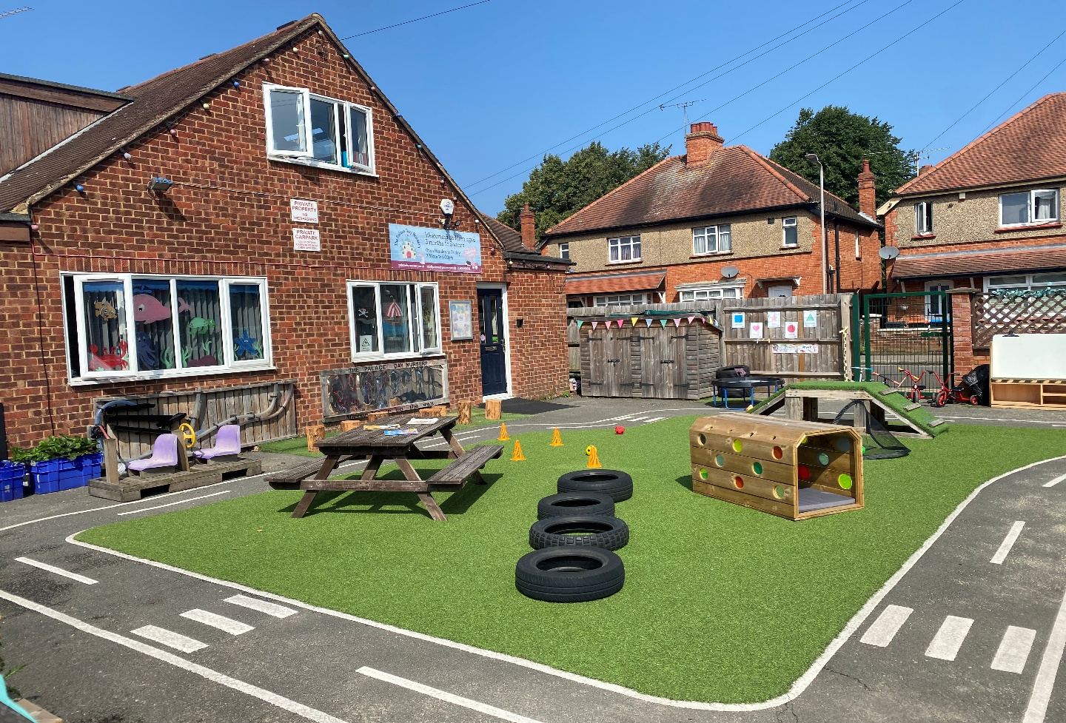
The Palace Day Nursery offers a warm, caring, stimulating and welcoming environment for all our children and families. By providing a wide range of activities and learning experiences, we build the foundation of a bright and healthy future and therefore the best start in life. We pride ourselves on building strong relationships with our parents, by settling in the children and their families to our nursery by working with them in partnership.
We are passionate about creating an enabling environment that has been carefully planned to follow each child’s individual needs and interests. We feel that children’s learning flourishes through curiosity, investigation, exploration and by continuously discovering and experiencing new things. Our enthusiastic staff facilitate these learning experiences by supporting them as they develop in all areas of learning whilst keeping them safe and secure.
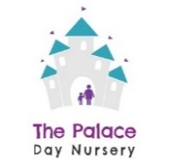
Your Child
Child's Full Name _________________________________ Name usually known by ______________________
Date of Birth _________________________________ Gender ____________________________
Religion _________________________________ Nationality ____________________________
Proposed Start
Date _________________________________ Childs ID ____________________________

Parent 1
Full Name _________________________________ Relationship to
Child ____________________________
Address __________________________________________________________________________________
Phone Number Mobile Number Email Address
____________________ _____________________ ___________________________________________
Occupation/Employer Work Phone Number Permission to Collect
____________________ _____________________ ____________________________________________
Parent 2
Full Name _________________________________ Relationship to
Child ___________________________
Address __________________________________________________________________________________
Phone Number Mobile Number Email Address
____________________ _____________________ ___________________________________________
Occupation/Employer Work Phone Number Permission to Collect
____________________ _____________________ ___________________________________________

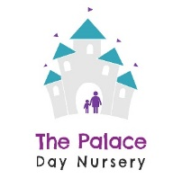
Emergency Contact 1
Full Name _________________________________ Relationship to
Child ___________________________
Address __________________________________________________________________________________
Phone Number Mobile Number Email Address
____________________ _____________________ ___________________________________________
Permission to Collect Collection Password
____________________ _____________________
Emergency Contact 2
Full Name _________________________________ Relationship to
Child ____________________________
Address __________________________________________________________________________________
Phone Number Mobile Number Email Address
____________________ _____________________ ___________________________________________
Permission to Collect Collection Password
____________________ _____________________

Other People with Parental Responsibility
Full Name ______________________ Relationship to
Child ____________________________
Address ___________________________________________________________________________________

Doctor
Doctor’s Name ___________________________ Phone Number ____________________________
Practice Name ______________________________ Address _________________________________
_________________________________
Name of Health Visitor ___________________________ Phone Number ___________________________

Fees
Non Funded Fee Structure 2026
Session Time | Daily Fees | Hourly Rate
7:30am to 6pm | £87.00 | £8.29
7:30am to 4pm | £83.00 | £9.76
7:30am to 1pm | £54.50 | £9.91
1pm to 6pm | £51.00 | £10.20

All non funded sessions include, breakfast, lunch, tea as well as morning and afternoon snack. Water is provided and available all day, additional charges apply for all meals and snacks provided during funded hours.

A non-refundable Administration fee of £50.00* (per child) and a refundable deposit of 50% of a full month’s fee with a minimum of £250.00 upon completion of registration to secure your child’s place at nursery. This deposit will be refunded in the 1st full month of your child starting.

* The Administration fee is not applicable if your child will be accessing funded only sessions.

Please tick the sessions you would like your child to attend with us:
 | 7:30am to 6pm | 7:30am to 4pm | 7:30am to 1pm | 1pm to 6pm
Monday
Tuesday
Wednesday
Thursday
Friday
Government Funding
Every child is entitled to access Early Years funded places. At The Palace Day Nursery we accept funding from 9 months to 5 years. (Places are limited and subject to availability).
The Government funding is not intended to cover the costs of meals, consumables, additional hours or services. Therefore, we ask for a voluntary additional service fee of £1.75 on all funded only hours as a contribution towards these. (Please see below for breakdown)
Parents who do not wish to access these services will be responsible for providing their child with everything they need when attending the nursery, subject to our rules on the provision of food. Their child will remain within our EYFS provision whilst our extra-curricular activities are taking place.
Families who are unable to pay for additional services and hours and wish to opt out can still access a place, however at the Palace Day Nursery we have a limited number of fully funded sessions available.
The current breakdown of costings for our additional services are as follows –
(Please note the cost of each item has been subsidised when paying our additional services fee)

Access to Famly, Learning Journey’s and Observations £3.00 per day
Snacks £2.00 per session
Extra-curricular activities – Sporty Scholars, Language workshops, External music sessions,
Groovy Movers, Yoga and Zumba £8.00 per week
Celebrations, Cultural events, ECO projects £5.00 per week
Life skills ie Baking and Gardening activities £3.00 per week
Toiletries and Calpol £3.00 per week
Contribution towards specialist staff training and subscriptions £5.00 per week
Community trips and visits (additional staff ratio costs when leaving site) £5.00 per week
Specialist spare clothing £1.00 per week

Funding – costs for meals
Breakfast £1.00
2 Course Lunch £3.50 (under 2 year olds)
2 Course Lunch £4.50 (2, 3 & 4 year olds)
2 course High Tea £2.50 (under 2 year olds)
2 course High Tea £3.50 (2, 3 & 4 year olds)

Parents who do not wish to access the above services and therefore choosing to opt out of the additional services charge please tick below.
☐

If your child is entitled to funding, please provide the following details to enable us to claim funding on your behalf:
Funding Code | Parent / Carers full name | Parent/ carers  Date of Birth | National Insurance Number
Applied for Code  Yes / No | Parent / Carers full name | Parent/ carers  Date of Birth | National Insurance Number

If your child attends another setting
If your child attends another setting, please let us know when and where they attend so that we can take your existing routine into consideration when allocating a place.
If your child is accessing funding in another setting, please indicate below –

Name of other setting | Days / sessions attending | Number of hours taken
Monday
Tuesday
Wednesday
Thursday
Friday

Medical Information and Wellbeing
Are immunisations up to date? Yes ☐ No ☐
Does your child have medical issues? Please detail any medical procedures, which are prohibited by your family, religion or belief. Please detail any religious or cultural considerations to be made when caring for your child.
Does your child have any known allergies or intolerances? Details

Please provide proof/guidance of any medical issues or allergies from your GP

Other dietary requirements :

Does your child have any additional needs you are aware of?

Is your child registered with a dentist? Yes ☐ No ☐

Does your child have regular checkups at the dentist? Yes ☐ No ☐

Wellbeing
Please provide details of any medical condition, health problem or allergy affecting your child; any learning difficulty, disability or special educational need as well as any behavioural, emotional and/or social difficulty of your child, if applicable (using a separate sheet if necessary).

Are there any other services involved with the child’s family?
If yes, please provide further information below.

Any information given will form the basis of a care plan for your child once they commence nursery. Please feel free to supply any other information necessary.
Consents
Emergency First Aid Yes No
I give permission for emergency First Aid and for staff to seek further medical advice or medical intervention in an emergency or if my child falls seriously ill whilst in the care of The Palace Day. ☐ ☐

Emergency Medical Treatment Yes No
I give my permission for a member of staff to accompany my child to hospital in an ambulance should the need arise. I understand that all medical decisions in my absence are the responsibility of medical professionals and that I will be contacted as soon as possible. ☐ ☐

Administer Medication
I give permission for the Nursery to administer medication as per instructions given Yes No
by me the parent. ☐ ☐

I give consent to my child being given the following medication in an emergency as required:
Liquid paracetamol/Calpol as per the instructions on the bottle ☐ ☐
Teething gel or powder which is to be supplied by the parent ☐ ☐

Plasters Yes No
I give consent for plasters to be used ☐ ☐

Sun Cream/Nappy Cream Yes No
I give permission for sun cream to be applied to my child (this must be supplied by the parents,
in advance) ☐ ☐
I give permission for nappy cream to be applied to my child whilst in the care of the Nursery ☐ ☐
I will Provide any other cream, eg: Eczema/ Nappy Cream ☐ ☐
Details of cream ……………………………………………………………………………………………………..

Famly Learning Journal – an online record of your child’s experiences and achievements
during their time with us*. Yes No
I give permission for my child’s learning journey to be taken home by their key person to be worked on outside of Nursery hours ☐ ☐
I give permission for photographs/videos of my child to be used on Famly, observations etc ☐ ☐
*Families who do not opt in to our additional services fees will not receive individual updates on Famly, we will keep them informed of their children’s learning and development verbally.

Eco Projects - Yes No
I am happy for my child’s photos to be included in the Eco accreditation award ☐ ☐

Photographs Yes No
Nursery Staff can use photographs of my child for displays and their peg including children’s names ☐ ☐
I give permission for photographs to be taken by a visiting Photographer (Notification of dates and times will be given) ☐ ☐
I give permission for my child to appear in photographs/videos in other children’s online learning journeys and in group photographs ☐ ☐

Website/Facebook/Instagram/Promotional Material Yes No
I give permission for my child’s photos to appear in the Palace Day Nursery Website ☐ ☐
I give permission for my child’s photos to appear in the Palace Day Nursery closed Parents
Facebook page ☐ ☐
I give permission for my child’s photos to appear on the Palace Day Nursery Instagram page ☐ ☐
I give permission for my child’s photos to appear in the Palace Day Nursery open Facebook page ☐ ☐
I give permission for my child to appear in nursery promotional leaflets ☐ ☐

Outings – occasionally we may take children for walks outside the Nursery registered premises Yes No
I give my permission for my child to be taken for walks outside the Nursery registered premises ☐ ☐
General Terms & Conditions
HOURS OF OPERATION
Monday to Friday 07:30 to 18:00. We will be closed on all statutory holidays, and these will be charged at normal rates. We will also close between Christmas Day and New Years Day and these are not charged. The nursery closes at 6pm promptly each day, late collections after 6pm will incur a charge of £5.00 per child. After 15 minutes this will be charged at £5.00 per every additional 5 minutes. This late fee will also apply to all other sessions across the day if you are late collecting your child.
ADMINISTRATION AND DEPOSIT FEE
Parents will be charged a non-refundable administration fee of £50.00* per child on completion of registration. All parents will be charged 50% of a full month’s fee (with a minimum of £250.00) as a deposit on booking with a completed registration form. The full deposit can be refunded if we are given a minimum 12 weeks’ notice prior to the child’s starting date if choosing not to take up the booked place. The full deposit will be deducted from the first full month’s fee of the child starting.
*Administration fee is not applicable if your child will be accessing funded only sessions.
MONTHLY FEES
Monthly fees are at the prevailing fee schedule. The setting reserves the right to increase said fees at any time giving one calendar months’ notice of the proposed increase to parents/guardians.
Monthly fees include all sick days and holidays taken as these are paid days. Fees are based on booked days not attendance. Refunds and credits will not be given for days where your child does not attend due to sickness or holiday.
Notice Period: We require a minimum of 4 weeks written notice to change or cancel your child’s normal booking. All fees will be due during this notice period.
Monthly fees are calculated as an average of a 12-month period from the month your child starts. Therefore, payment is divided into 12 monthly equal payments and payment is due throughout the year.

NHS and Sibling Discount
I understand that if I or my partner are an employee of the NHS or has a sibling attending the setting, then I am entitled to 5% discount of my nursery fees for the first 3 months, this only applies to the 1st child and if your child is not in receipt of government funding. (Please note, NHS employer card to be shown at registration and this discount ends once your child is entitled to funding or after the first 3 months of your child starting- whichever is first).

PAYMENT
Parents agree that all monthly fees (full time and part time attendance) will be paid on the first of each month in advance. Extra sessions will be invoiced at the end of the month.
Unpaid fees are subject to a £50 late payment fee. Unpaid fees may result in immediate suspension or termination of care unless reasonable arrangements are made and accepted by both parties.
Extra hours are billed at our private rates. Full time and part time fees are based on booked days, not attendance. Therefore, parents are responsible for fees whether their child attends or not (this includes sick days and holidays booked).
Payment of fees are by bank transfer only.
Childcare Vouchers, Tax-free childcare and Student Finance can also be used by prior arrangement. Please let our administrator know on registration.
Universal Credit
* You may be able to claim all or part of your nursery fees back via Universal credit. You may need a letter to support your claim. Please ask our administrator for details if Universal credit ask for one.
Please note that parents are responsible to pay any fees not covered by Universal credit.
I claim Universal Credit Yes ☐ No ☐

All fees are to be paid into the following account - Name: The Palace Day Nursery
Account Number: 70180971
Sort Code: 40-11-58

Please use your child’s name as reference.

DATA PROTECTION PRIVACY NOTICE FOR PARENTS AND CHILDREN
Collecting data
As a nursery it is necessary for us to collect personal information about you and your child. For the majority of data we collect, the lawful basis for doing so falls under the category of ‘legal obligation’ such as names, date of birth and addresses as we have a legal requirement to obtain this data. Some data we collect, for example, photographs of your child, requires you to give consent for us to do so. Where this is the case, you will be required to sign a consent form to ‘opt in’ and have the right to withdraw your consent at any time. You may also be required to provide data as part of your contract with the setting or local authority, for example, in order for us to claim government funding for your child. We will make sure that the information about you is accurate and up to date when we collect or use it. You can help us with this by keeping us informed of any changes to the information we hold about you. In order for us to collect data from you, you will be required to complete paper forms. The types of data we collect from you include:
- Full name (for you and your child)
- Your child’s date of birth
- Home address
- Religion and nationality
- Work address
- Telephone number(s)
- Photographs of your child (with consent)
- Names, contact numbers and addresses of your emergency contacts
- Your email address
- Your child’s medical conditions
- Any court order information relating to yourself or your child

Whilst your child attends with us, we may also collect the following information:
- Ongoing progress and development records
- Photographs
- Accident records
- Medical records
- Attendance records
- Safeguarding/child protection logs
- Your date of birth and national insurance number (for funding purposes)
- Birth certificate or passport number including date of issue (for funding purposes)

Sharing information with others
Sometimes we have to confirm or share information with other organisations. If we need to do this, we will make it clear to you on the forms you complete giving us the information. We will inform you before sharing any of yours or your child’s information. In some cases, a third-party organisation, such as a funding body, may require you to sign an agreement to allow your information to be shared e.g. on a funding form. Please read all paperwork thoroughly before signing, so that you know exactly how your information will be used.

Security
We will keep data about you and your child secure. We will protect your data against unauthorised change, damage, loss or theft. All data collected is only accessed by authorised individuals. All paper forms are kept locked away and all computers and tablets are password protected.

Data retention
We will hold information about you and your child only for as long as the law says and no longer than necessary. After this, we will dispose of it securely. Please see appendix i. of our General Data Protection Regulation policy for more information.

Access and correctness
Whenever possible, we will let you see the information we hold about you and correct it if it is wrong. This needs to be requested in writing.

Our Commitment
We will only collect information that is necessary for what we do. We will be fair in the way we collect information about you. We will tell you what we intend to do with the information about you. Where possible, we will collect information directly from you. If we collect information about you from someone else, we will make sure you know what information we hold on you, where possible and legal to do so.

General Data Protection Regulation (2018)
We will comply with the General Data Protection Regulation 2018 (GDPR) and any subsequent legislation on information handling and privacy. We will do this through Palace Day Nursery GDPR policy and procedures. We will support you with any questions or problems that you may have with the Data Protection Act 1998, General Data Protection Regulation 2018, the Human Rights Act 1998 or the Freedom of Information Act 2000. If we cannot help you, we will give you advice on where to get the information you may need.

CHANGES TO THIS PRIVACY NOTICE
We reserve the right to update this privacy notice at any time, and we will provide you with a new privacy notice when we make any substantial updates. We may also notify you in other ways from time to time about the processing of your personal information.

If you have any questions about this privacy notice or require a full copy of our GDPR privacy notice, please contact Lisa Blake (Nursery Manager).
I ……………………………………………………………. acknowledge that on......................................................., I accept the above Privacy notices. I am aware that I can request a full copy of the nurseries GDPR privacy notice at any time on request.

Signature.................................................................... Name.................................................................

Safety & Wellbeing
- If a child becomes unwell whilst in our care then we will contact the parents/carers, or the emergency contact detailed on the registration form. If senior staff feels the child is not well enough to remain at nursery, you may be asked to arrange collection of the child.
- In the case of sickness and diarrhoea your child will not be able to return to nursery until after your child has been clear from their last bout for 48hrs, this is also applicable to staff.
- The nursery will not administer any non-prescription medication that has not been prescribed for the exception of, Anti-histamine and teething gel/powder. Anti-histamine and Teething gel/powder is to be supplied by the parents. We do administer paracetamol and Calpol, cough linctus with parents’ consent.
- If a child is unwell, we ask that you contact the nursery to inform them of the absence. The nursery must be informed if the child is suffering from any contagious disease to ensure we can effectively communicate to all parents any communicable diseases in the nursery. For the benefit of other children, we ask you to withhold the child from the nursery if they are suffering from a contagious disease that could easily infect others.
- I agree that if my child is sent home and a parent/carer obtains prescribed medication my child cannot return to nursery until they have had 2 clear doses
- I understand that I must inform the nursery that someone other than myself will be collecting my child and they are required to present ID and give their stated password.
- I understand that any practitioner who suspects safeguarding concerns with a child in their care does have a legal duty to report this to the Multi Agency Safeguarding Hub (MASH). In exceptional cases this may be done without speaking to a parent/carer until we have sought external advice.
- I understand that where I have safeguarding concerns with regards to a member of Palace Day Nursery staff, I have the right to report to the Local Authority designated officer.
- We use CCTV in various locations around the Nursery site to ensure it remains safe. We will adhere to the ICO’s code of practice for the use of CCTV. Security cameras are clearly visible and accompanied by prominent signs explaining that CCTV is in use.
- Palace Day Nursery cannot take responsibility or liability for any services provided by our staff outside of our provision (such as babysitting). If you use any of our employees to provide services to you, you acknowledge and agree that this is done entirely at your own risk.
- We will work with you to cater for specific dietary and medical requirements of individual children. You have a duty of care to notify the nursery in writing if there are changes to a special diet or medical condition so that we can ensure all paperwork is updated. Any information by a medical professional must be shared with the nursery.
- In exceptional circumstances there may be an event that triggers the closure of the nursery that is out of our control. Such events include, without limitation, ‘acts of God’, fire, war, acts of terrorism, strikes or other industrial action, infectious diseases, and epidemics, and Palace Day Nursery will not issue refunds for such forced closures.
- Palace Day Nursery will not tolerate, under any circumstances, behaviour towards staff which is deemed to be threatening, abusive or violent. Any such behaviour may result in termination of the nursery place or a refusal to allow the person back on the premises in the future. We may suspend the provision of childcare if your child’s behaviour at the nursery endangers the safety and wellbeing of the other children at the nursery. The suspension shall continue whilst we try and address these problems with you.
- Palace Day Nursery reserves the right to change any element of these T&Cs without notice where such a change arises from regulatory or legal requirements, or by providing reasonable notice for non-regulatory or statutory amendments.
- Palace Day Nursery does not accept responsibility for accidental injury or loss of property. Therefore, please ensure that all your child’s items are clearly labelled
Nursery Daily Checklist
Children of all ages will need to bring the following items to nursery on a daily basis. Please ensure that all items are clearly labelled with your child’s name.
- At least two spare sets of clothes, weather suited outdoor clothes & shoes (i.e. wellies, hats, gloves, scarves, sunhat & suncream)
- Please provide a separate pair of indoor shoes (slippers) to change into when entering the building
- Please provide your own water bottles.
For babies or toddlers, you may also need to bring the following:
- Milk or water bottles. This is so we are able to accommodate every individual preference for teat and bottle shapes.
- Any creams or lotions that you would like us to apply to your child (i.e. nappy cream)
Please note that parents would also need to provide nappies, wipes & all milk formula.
Meals and Snacks
At the Palace Day Nursery we promote healthy eating and lifestyles. We adhere to the DFE Early Years Nutrition Guidance and EYFS.
Our highly experienced and qualified chef uses the Eat Well, NHS Changes for Life & Start for Life guidance when menu planning. We have stringent policies in place with regards to allergies and allergens, cultural and religious requirements and individual dietary needs. Our menu’s embrace a wide range of fresh seasonal and homemade products and an opportunity to try new foods.
We do not permit children to bring in pack lunches or any foods from home, this is to ensure that everyone follows our Healthy Eating approach in providing healthy, balanced and nutritious food. Our priority is to keep children safe, avoiding the risk of cross contamination from allergens and allergies and accommodate cultural or religious beliefs.

Meals and Snacks cont…
We promote an enjoyable experience for the children at meal and snack times, whilst encouraging self-help skills and good manners. Children are always supervised during meals to promote safe eating practices and to minimize the risk of choking. A full copy of our Nutrition and Mealtimes policy is available on request.

Acceptances
a. Our terms and conditions are considered to be fair and reasonable. In the event of any term found by a Court of Law to be unreasonable then the clause shall be removed but the agreement shall remain in full force and effect.
b. The parent/guardian has read and understands the Terms and Conditions contained and undertakes to be bound by the same. This agreement must be signed by persons with Parental Responsibility and/or those who are accepting responsibility for paying fees.
We will only use your personal information in relation to our childcare service.
We would like to keep sending you information about our nursery by email/Facebook/phone/other (as applicable) but we need to be sure we have your permission to do so. We will keep your information so that you can receive important updates about our nursery. We will keep your information secure and will never share it except if required to do so by law.
We expect all parents/carers to read and adhere to our policies and procedures regarding illness and absence, medication, dietary requirements, safeguarding children, security, behaviour, equal opportunities, complaints and Opt out policy among others. All relevant policies can be accessed at the setting or found on our website https://www.palacedaynursery.co.uk/
By ticking this box, you are consenting to us continuing to holding and processing your data and sending you information. You can of course unsubscribe / ask us not to contact you by email / phone / Facebook etc. at any time. ☐

I have read, understood and agree to the policies and conditions included in this registration document.
I hereby agree to all terms and conditions.
Signature....................................................................Name.........................................................................

Relationship to the child................................................................. Date.......................................................

